CTM-I Use Case

Generic Parm Edit

Version 0.1

Use Case Name | Generic Parm Edit
Actor | App Support
Pre-conditions /Assumptions | User has selected Edit from the Parm Browse for a specific record.
Post Conditions | User can return to the Parm Browse by selecting the “Return to Browse” link. This will return to the Parm Browse as use the user’s last criteria and sorting to display the search results.
Screenshot | 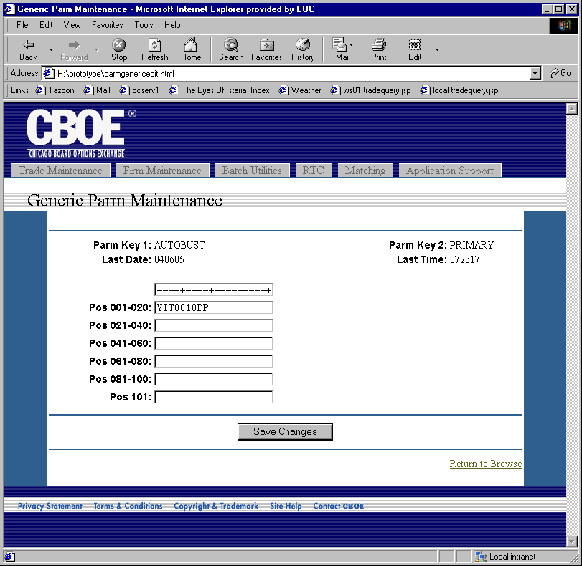
Flow of Events | - Request is sent to CTM-R to retrieve the parm.  - Generic Parm Maintenance screen is displayed with the data from the parm.  - Read-Only fields are  - Parm Key 1  - Parm Key 2  - Last Date  - Last Time  - Editable data field is broken into sections to make editing easier.  - User can press the “Save Changes” button to save the changes.  - Changes will be sent to CTM-R to process  - Results of the CTM-R processing will display on the screen.
Alternative Path | When the request to edit a parm is received, the parm is checked to see if it fits the criteria for a Parm Definition. If the parm does match the criteria for a Parm Definition, then the request is passed to the Dynamic Parm Edit Use Case.

